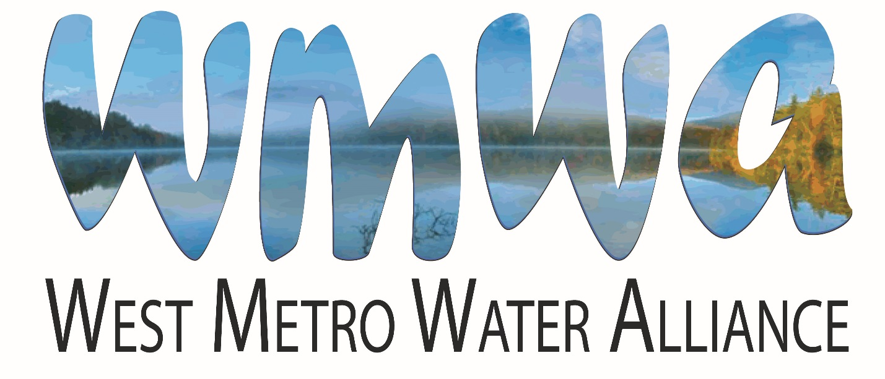

2019 Annual Report

Background
In 2006 the Shingle Creek and West Mississippi Watershed Management Commission’s Education and Public Outreach Committee (EPOC) invited the Education Committee of the Bassett Creek Watershed Management Commission to partner in developing joint education and outreach activities. Since that time this voluntary partnership has grown to include the Elm Creek Watershed Management Commission, the Three Rivers Park District, Hennepin County Department of Environment and Energy, and the Freshwater Society. The WMOs are designated as “members,” the latter three organizations as “partners.”
This alliance, the West Metro Water Alliance (WMWA), grew from a recognition that the individual organizations have many common education and public outreach goals and messages that could be more efficiently and effectively addressed and delivered collaboratively and on a wider scale.
Meetings
WMWA meets monthly, as needed, on the second Tuesday, at Plymouth City Hall. Member representatives include Laura Jester, Bassett Creek WMC Administrator; Doug Baines, Commissioner, Elm Creek WMC; Catherine Cesnik, Plymouth, Elm Creek WMC and WMWA Coordinator; and Shelley Marsh, Brooklyn Center, and Ben Scharenbroich and Amy Riegel, Plymouth, Shingle Creek, Elm Creek and West Mississippi WMCs. Other attendees include Mary Amsden and Sharon Meister, Watershed PREP Educators; and Dawn Pape, DBA Lawn Chair Gardener. Diane Spector, Wenck Associates, serves as technical support for WMWA, and Amy Juntunen, JASS, serves as administrative support. In 2019 eleven meetings were held. All WMWA member Commissioners and city staff are welcome to attend meetings.
The WMWA Program
Goals of the WMWA program are to:
▪ Inform the public about the watershed organizations and their programs.
▪ Provide useful information to public on priority topics.
▪ Engage the public and encourage positive, water-friendly behaviors.
Three informational pieces have been developed by WMWA to support these goals. The 10 Things You Can Do Brochure targets the general public. The brochure is distributed at all venues where the Commissions or member cities have a presence and also in the Watershed PREP classrooms. It is also available on the websites of the WMO member cities. In 2019 the 10 Things brochure was updated and reprinted in partnership with Hennepin County.
The Maintain Your Property the Watershed Friendly Way handbook targets small businesses, multi-family housing properties, and common interest communities such as homeowners’ associations. It contains tips for specifying and hiring turf and snow maintenance contractors, and includes checklists for BMP inspections.
The Residential Snow and Ice Care brochure is an educational piece designed to inform citizens of the chloride pollution problem and ways to reduce salt use.
Watershed PREP and Community Events
Watershed PREP is a program of WMWA and stands for Protection, Restoration, Education, and Prevention. 2019 was the seventh year of the program. Two contract educators with science education backgrounds are shared between the member watersheds. The focus of the program is two-fold - to present water resource-based classes to fourth grade students and to provide education and outreach to citizens, lake associations, other civic organizations, youth groups, etc. Goals of the program are 1) to have audiences gain a general understanding of watersheds, water resources and the organizations that manage them, and 2) to have audiences understand the connection between actions and water quality and water quantity. The ultimate goal is to make this program available to all fourth graders in the four WMWA watersheds and to other schools as contracted.
Fourth Grade Program. Three individual lessons meeting State education standards have been developed. Lesson 1, What is a Watershed and Why do We Care?, provides an overview of the watershed concept and is specific to each school's watershed. It describes threats to the watershed. Lesson 2, Water Cycle - More than 2-dimensional!, describes the movement and status of water as it travels through the water cycle. Lesson 3, Stormwater Walk, investigates movement of surface water on school grounds.
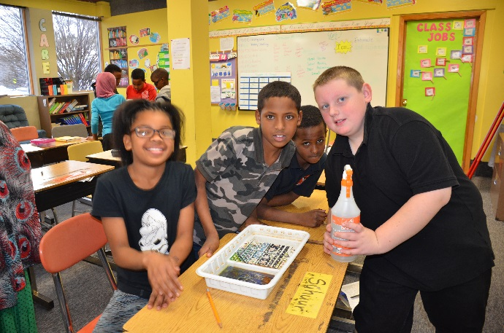 | In 2019, 103 classes totaling 2,681 students participated in Lesson 1. Of those classes, 58 totaling 1,516 students also participated in Lesson 2. Since the inception of the program in 2013, a total of 669 classrooms and 17,463 students have participated in Lesson 1 and 5,886 students in 217 classes participated in Lesson 2. Appendix A details the students reached in lessons 1 and 2. The PREP educators also provided Community Education and Outreach at three school and community water-related events using the large model watershed "Enviroscape" for runoff education. Outreach activities are also described in Appendix A.

Updated Work Plan
In 2015 the WMWA Work Plan was updated to reflect current practices. The updated Work Plan identified the following activities:
- Facilitate information availability and sharing.
- Reschedule professional opinion survey to measure knowledge and attitudes about water resources to 2019.
- Provide Coordinated Communication, Media Relations, and Information Sharing that more closely parallel what the NPDES Permit education and public outreach minimum measure require. Components include identifying priority issues every year, developing a communications plan that identifies educational goals by stakeholder, establishing measurable goals, and identifying responsible parties.
- Develop county-wide or regional activities. (At this time WMWA does not have the capacity to undertake these activities.)
- Pursue and obtain funding for education and public outreach activities.
- Support and expand in scope and reach the Watershed PREP program.
WMWA’s 2019 and 2020 budgets reflect these activities and were approved by the members on January 16, 2018 and January 8, 2019, respectively. The budgets are included in this report as Appendix C.
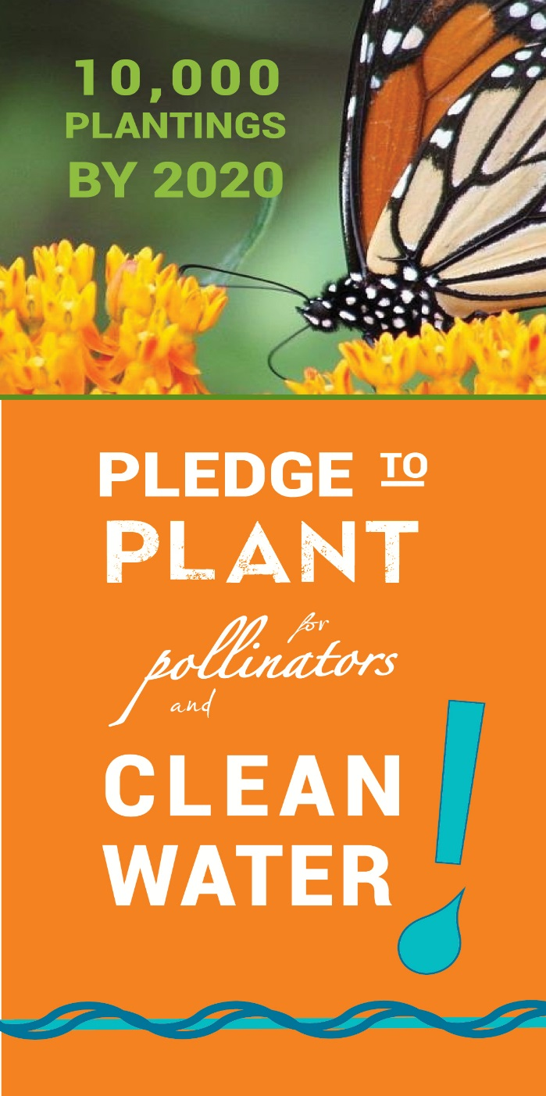
Special Project
Pledge to Plant was a project started in 2016 to encourage residents to replace impervious surface and turf grass with native plantings to benefit clean water by reducing stormwater runoff. The project includes the additional benefit of creating habitat for pollinators.
Phase one of the project began with creation of a name, tag line and logo. The project was promoted in the Blue Thumb space at the State Fair where the public voted to name the campaign, Pledge to Plant for Pollinators and Clean Water.
Phase two included a roll out of the Pledge campaign on the Metro Blooms and WMWA websites where citizens can enter the square footage of their new plantings, creation of a Pledge to Plant banner for events, and a social media campaign that began in May 2016. The Campaign was promoted at the State Fair and other area events in 2016 and 2017. Metro Blooms discontinued support of the program efforts in 2018.
In 2019, only 12 people submitted Pledges online. Since the program launched in 2016 there are over 642 total pledges covering over 430 acres, although several submissions did not specify an area to be planted, so it may be more. The total includes a few larger prairie restoration projects but the median pledge covers 200 square feet. Most of the pledges come from the metro area, but pledges have been received from 20 other states.
This program was discontinued at the end of 2019 due to the launch of a competing program, Lawns to Legumes, by the Board of Soil and Water Resources in partnership with Metro Blooms and the decision to focus WMWA resources elsewhere.
WMWA Coordinator Position
In the fourth quarter of 2019, members re-evaluated spending on the current Special Project. Looking forward to the needs of 2020 and the future, members voted to use Special Project funding for 2020 to hire a WMWA Coordinator as members did not have enough time to dedicate to certain upcoming projects, such as a survey to inform the update of the Work Plan, planned for 2020. Catherine Cesnik applied and was approved for the position beginning January 1, 2020.

Resilient Yard Workshops
In 2019, three Resilient Yard workshops and one Healthy Soils workshop, hosted by WMWA member cities and presented by Metro Blooms were held. Workshops took place in Plymouth, Champlin, Crystal, and Golden Valley. Attendees learned about raingardens, native plantings, turf alternatives or “bee lawns.”
Other practices were also discussed including stormwater recapture and reuse with rain barrels, diversion of downspouts away from impervious surfaces, and use of pervious pavers for driveways and patios, as well as how to develop and maintain healthy soil microbiology. Over 90 WMWA area residents attended the Resilient Yard workshop and 25 attended the Healthy Soils workshop.
Sherman Associates, owners of Autumn Ridge Apartments in Brooklyn Park, applied for a grant from the Shingle Creek WMC in 2018 for a Phase I of a project which includes the design and installation of five raingardens, a permeable pavement system, a large native planting at the corner of the property and a new playground, pending application and receipt of grant funding from Hennepin County and the Shingle Creek Watershed Management Commission. A Resilient Yard workshop was held on site for residents in fall 2017 with the planting project occurring in fall 2018.
In 2019 the Phase II grant application was submitted for additional on-site water quality treatment through installation of 7-8 new rain gardens, additional pollinator habitat and educational signage. The project includes additional resident education and participation in both the design and installation process and a five-hour Smart Salting class focused on parking lots and sidewalks for the on-site property managers.
Winter Maintenance Training
In 2019, Winter Maintenance Training workshops were held at Plymouth City Hall on August 29 and at Crystal Community Center on September 26 with 50 and 32 attendees, respectively. Attendees learned how to adjust the use of salt de-icing products to be effective without over-use. A Smart Salting for Property Managers workshop was hosted by Bassett Creek WMC on September 24 with 15 attendees. This workshop focused on how property managers can reduce chlorides. The Smart Salting workshops are provided by Fortin Consulting.

WMWA Website
The WMWA website www.westmetrowateralliance.org serves as a repository for documents and information for access by member cities and citizens, lists local events WMWA is participating in and/or otherwise promoting, stores Watershed PREP information for schools, and collects information for the Pledge to Plant campaign and newsletter subscriptions.
The website had 672 unique visitors engaged in 771 individual sessions with an average of 1.6 pages viewed per session for a total of 1250 page views on the website in 2019. The website metrics can be found in Appendix B
10 Things Brochure Update
In 2019 WMWA members, in coordination with Hennepin County staff, updated the 10 Things brochure. The new brochure is formatted to match other Hennepin County promotional materials and included updated language and slight modifications to the 10 recommended activities. The updated brochure was finalized in June 2019. Hennepin County provided printing services and provided 10,000 brochures to WMWA at no cost for distribution at Watershed PREP lessons and other outreach events.
2019 Marketing Activity
In May 2016 WMWA contracted with Dawn Pape, Lawn Chair Gardener, LLC, to create a social media campaign for the Pledge to Plant campaign and WMWA in general on Facebook and Twitter. As of December 31, 2019, the WMWA Twitter page had 138 followers. The most well-received Tweet was “Right on @MonarchsJV” with a reach of 1,978 and 20 engagements. Overall there were 52 Tweets in 2019 with a reach of 13,041 and 251 engagements. The Facebook page had 151 likes and 162 posts resulting in 624 engagements.
To learn more about WMWA, contact:
Diane Spector, Wenck Associates, 763.479.4280, dspector@wenck.com
or Amy Juntunen, JASS, 763.553.1144, amy@jass.biz

Appendix
Appendix A – Watershed PREP / Educator Activity

Table 1. 2019 Community education and outreach participation
Date | Event | Location |  | Watershed | # of Attendees
4/27 | Arbor Day Event | Maple Grove |  | EC/SC | Tree planting | 62 kids
8/1 | Plymouth Kids Fest | Plymouth |  | BC/EC/SC | 4000 attendees
11/12 | Meadowbook Elementary | Golden Valley |  | Bassett Creek | Filmed PREP class for video promotion

Community Education and Outreach. The PREP educators provided outreach at 2 community and school events. Because of the nature of these events, it is difficult to keep a tally of the number of contacts made and citizens engaged.

Table 2. Watershed PREP Program participation growth.
Year | # Classrooms | # Students | # and Type of Schools
Lesson 1
2013 | 63 | 1,679 | 13 in six districts; one charter school; one parochial school
2014 | 116 | 3,469 | 30 in seven districts; one magnet school; one parochial school
2015 | 122 | 3,183 | 36 in nine districts; two charter schools; five parochial schools
2016 | 107 | 2,850 | 29 in seven districts, one charter school, 5 parochial schools
2017 | 125 | 3358 | 12 in seven districts, one charter school, one parochial school
2018 | 143 | 3593 | 34 in eight districts, one charter school, two parochial schools
2019 | 103 | 2681 | 27 in six districts, one parochial school
Lesson 2
2013 | 14 | 390 | Three in three districts; one charter school; one parochial school
2014 | 22 | 645 | Five in three districts
2015 | 27 | 859 | Six in five districts
2016 | 20 | 524 | Five in three districts, one parochial school
2017 | 38 | 1,072 | Seven in three districts, one parochial school
2018 | 69 | 1755 | 17 in five districts, one parochial school
2019 | 58 | 1516 | 15 in five districts
*Includes eight classrooms in the Minnehaha Creek Watershed District paid for by others.
Appendix A – Watershed PREP / Educator Activity
Table 3. 2019 schools and students participating in Lesson 1: What is a Watershed?
 | Date | School | School District | City | Watershed | Classes | Students
1 | 2/28 | Hassan | Elk River | Rogers | Elm | 4 | 119
2 | 2/21 | Lakeview Elementary | Robbinsdale | Robbinsdale | Shingle | 3 | 62
3 | 3/25 | Plymouth Creek | Wayzata | Plymouth | Bassett | 4 | 110
4 | 3/27 | Sunset Hill | Wayzata | Plymouth | Bassett | 4 | 116
5 | 4/4 | Neill Elementary | Robbinsdale | Crystal | Bassett | 3 | 68
6 | 4/12 | Gleason Lake | Wayzata | Plymouth | Minnehaha | 4 | 92
7 | 4/30 | Meadow Ridge Elementary | Wayzata | Plymouth | Elm | 4 | 116
8 | 5/1 | Meadow Ridge Elementary | Wayzata | Plymouth | Elm | 2 | 58
9 | 5/3 | Oakwood | Wayzata | Plymouth | Minnehaha | 3 | 84
10 | 5/13&15 | Kimberly Lane | Wayzata | Plymouth | Bassett | 6 | 145
11 | 5/14 | Zachary Lane Elementary | Robbinsdale | Plymouth | Bassett | 4 | 96
12 | 4/30 | Northport Elementary | Robbinsdale | Brooklyn Ctr | Shingle | 2 | 45
13 | 5/14 | Forest Elementary | Robbinsdale | Crystal | Shingle | 3 | 83
14 | 5/21&22 | Rush Creek | Osseo | Maple Grove | Elm | 5 | 127
15 | 9/25 | Noble Elementary | Robbinsdale | Golden Valley | Bassett | 2 | 52
16 | 10/1 | Rice Lake | Osseo | Maple Grove | Elm | 3 | 73
17 | 10/3 | Rice Lake | Osseo | Maple Grove | Elm | 2 | 47
18 | 10/4 | Rice Lake | Osseo | Maple Grove | Elm | 2 | 46
19 | 10/9-10 | Elm Creek Elementary | Osseo | Maple Grove | Elm | 4 | 93
20 | 10/16/19 | Monroe Elementary | Anoka-Hennepin | Brooklyn Park | W. Miss | 4 | 112
21 | 10/23 | FAIR Pilgrim Lane | Robbinsdale | Crystal | Shingle | 1 | 24
22 | 10/24 | SEA | Robbinsdale | Golden Valley | Bassett | 3 | 84
23 | 10/30 | Rogers | Elk River | Rogers | Elm | 4 | 116
24 | 10/31 | Palmer Lake | Osseo | Brooklyn Park | Shingle | 3 | 70
25 | 11/4-5 | Weaver Lake | Osseo | Maple Grove | Elm | 4 | 118
26 | 11/11 | Good Shepherd | Parochial | St. Louis Park | Bassett | 2 | 33
27 | 11/15 | Meadowbrook | Hopkins | Golden Valley | Bassett | 2 | 55
28 | 11/19-20 | Dayton | Anoka-Hennepin | Dayton | Elm | 3 | 85
29 | 11/21-22 | Oxbow Creek | Anoka-Hennepin | Champlin | W. Miss | 7 | 191
30 | 11/25-26 | Basswood | Osseo | Maple Grove | Elm | 6 | 161
 |  |  |  |  | Total: | 103 | 2681
Appendix A – Watershed PREP / Educator Activity

Table 4. 2019 schools and students participating in Lesson 2: The Incredible Journey
 | Date | School | School District |  | Watershed | Classes | Students
1 | 2/27 | Hassan | Elk River | Rogers | Elm | 4 | 118
2 | 2/6 | Lakeview Elementary | Robbinsdale | Robbinsdale | Shingle | 3 | 61
3 | 4/3 | Neill Elementary | Robbinsdale | Crystal | Bassett | 3 | 68
4 | 4/23&24 | Rush Creek | Osseo | Maple Grove | Elm | 5 | 127
5 | 29-Apr | Northport Elementary | Robbinsdale | Brooklyn Ctr | Shingle | 2 | 46
6 | 5/7 | Forest Elementary | Robbinsdale | Crystal | Shingle | 3 | 84
7 | 9/30 | Rice Lake | Osseo | Maple Grove | Elm | 3 | 71
8 | 10/3 | Rice Lake | Osseo | Maple Grove | Elm | 2 | 47
9 | 10/7-8 | Elm Creek | Osseo | Maple Grove | Elm | 4 | 92
10 | 10/14-15 | Basswood | Osseo | Maple Grove | Elm | 6 | 175
11 | 10/22 | Rogers | Elk River | Rogers | Elm | 4 | 118
12 | 10/23 | FAIR Pilgrim Lane | Robbinsdale | Crystal | Shingle | 1 | 24
13 | 10/29 | Palmer Lake | Osseo | Brooklyn Park | Shingle | 3 | 68
14 | 11/6-7 | Oxbow Creek | Anoka-Hennepin | Champlin | W. Miss | 7 | 194
15 | 11/8 | Meadowbrook | Hopkins | Golden Valley | Bassett | 3 | 83
16 | 11/12 | Meadowbrook | Hopkins | Golden Valley | Bassett | 2 | 56
17 | 11/18-19 | Dayton | Anoka-Hennepin | Dayton | Elm | 3 | 84
18 |  |  |  |  | Total | 58 | 1516

Evaluation:
The educators evaluate the success of the Fourth Grade Program by surveying students and teachers about the quality of the program, the learning that was observed, and the performance of the educators. Much of the feedback occurs during and right after the presentations in spontaneous comments.

Appendix B – Website/Social Media Activity
Facebook: Eleven posts were “boosted” in 2019 to reach a greater audience. The return was minimal. Likes grew in 2019 by six for a total of 151 likes. The maximum post reach was 211 and maximum post engagements was 92.

Appendix C – Budget

 |  | 2018 |  |  |  | 2019 |  |  |  | 2020
 |  | Budget | Revenue | Expense | Balance | Budget | Revenue | Expense | Balance | Budget⁴
Admin/Tech Services |  | $16,000 | $8,000 | $10,069 | $0 | $12,000 | $12,000 | $11,599 | $401 | $12,000
 | Routine tasks, website, social media, meetings, etc
Special Projects¹ |  | 8,000 | 4,000 | 3,916 | 5,078 | 8,000 | 8,000 | 3,879 | 9,199 | 8,000
Watershed Prep |  | 18,000 | 9,000 | 14,659 | 8,908 | 16,000 | 8,382 | 12,326 | 4,964 | 16,000
Resilient Yards² |  | Billed directly to cities |  |  |  | Billed directly to cities
 | Metro Blooms workshops
TOTAL |  | $42,000 | $21,000 | $28,644 | $13,986 | $36,000 | $28,382 | $27,804 | $14,564 | $36,000

